 

International internship

Internship report of international context Julien Juncker

2020

Instituto Politécnico de Castelo Branco JUNCKER Julien

Castelo Branco A4 - Groupe 1

TORRES Paulo Jorge Dias BRUNELOT Romain

*Mode de diffusion :*

Restreinte Résultat de recherche d'images pour "checkbox" Libre □

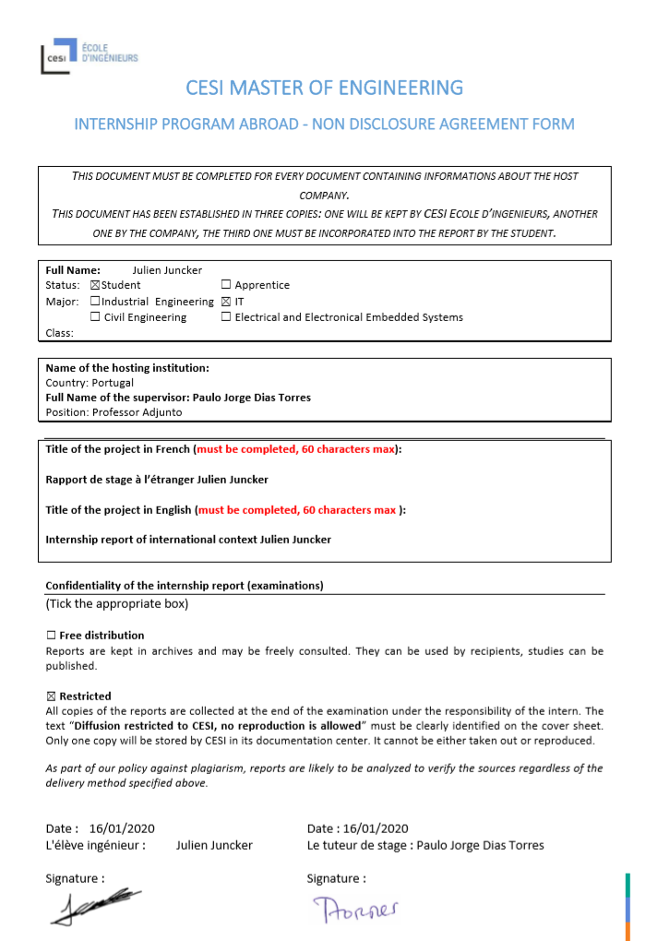

Table des matières

Tables of figures 5

Acknowledgement 6

Abstract 7

Résumé 8

Context of internship 9

School presentation 10

Polytechnic institute of Castelo Branco 10

School of technology of Castelo Branco 12

Mission context on school 13

Mission – Bee project 14

Abstract of the bee project mission 14

Introduction of bee project 14

IoT system in bee project 15

The object 16

Networks 18

Data 21

Information 22

Operating application 22

Presentation of bee solution 24

Mission – R.D.R Project 29

Abstract of R.D.R mission 29

Web solution in R.D.R mission 29

Website of R.D.R Project 30

RFID system in R.D.R Project 31

Shock of culture 31

Cultural difference compared to lived experience 31

Difference of practice in professional domain 33

Conclusion 35

Conclusion of career path 38

Conclusion of culture 38

References 39

# Tables of figures

Figure 1. District of Castelo Branco in Portugal 9

Figure 2. Position of the city of Castelo Branco 9

Figure 3. Statistics of the population of Castelo Branco district compared to its age group 10

Figure 4. The size higher schools of IPCB 11

Figure 5. Evolution of number of new students in IPCB 11

Figure 6. All the formation available on ESTCB 13

Figure 7. Table of the general characterization of beekeeping in Portugal in 2013 and 2015 15

Figure 8. The 5 main steps of IoT project 16

Figure 9. Comparison with different programming card 17

Figure 10. Comparison with different temperature sensors 17

Figure 11. Weight sensor with Arduino/esp8266 component 18

Figure 12. Bee project network structure 19

Figure 13. Networks architecture for short distance 19

Figure 14. Comparison between LoRaWAN and SIGFOX networks 20

Figure 15. LoRaWAN architecture 20

Figure 16. Network architecture for long distance 21

Figure 17. Table of all necessary information for first solution of bee project 22

Figure 18. Comparison between LAMP and MEAN web stack 23

Figure 19. Flowchart electronic part of bee project solution 24

Figure 20. Electronic circuit of esp8266 board with sensors 25

Figure 21. Bee project electronic prototype 25

Figure 22. Flowchart of database algorithm in webserver 26

Figure 23. Database structure of bee project 27

Figure 24. Flowchart of website algorithm in webserver 28

Figure 25 . Bee Project website 29

Figure 26. R.D.R web solution architecture 30

Figure 27. R.D.R website 30

Figure 28. R.D.R electronic prototype 31

Figure 29. Tourism as a percentage of GDP in selected OECD countries (2016) 33

Figure 30. Average of gross salary on Portugal 34

Figure 31. Unemployment rate in Portugal 34

Figure 32. Screen of Trello for bee project and R.D.R 35

Figure 33. Planning of objectives on R.D.R project 36

Figure 34. Planning of objectives on bee project 37

# Acknowledgement

It is always a pleasure to remind the fine people in the polytechnic institute of Castelo Branco for their sincere guidance I received to uphold my practical as well as theoretical skills in engineering.

Firstly, I would like to thank Prof. Torres Paulo (Teacher of telecommunication) for accepted my internship request and to have accompanied me throughout this period.

Secondly, I would like to thank Mr. Formiga Fabio (student on the school and collaborator on the bee project) to welcomed me in the school, followed me into the project and share knowledge in telecommunication and IoT.

Thirdly, I would like to thank Mr. Malhão Sergio (Engineer of telecommunication) to also share knowledge in telecommunication and to welcomed me in the school.

I would like to thank Mr. Brunelot Romain (teacher of informatic in CESI school) for follow-up during this internship and to respond to my answer about the report when I needed.

Finally, I apologize all other unnamed who helped me in various ways to have a good training.

# Abstract

For the period of 27th September 2019 to 7th February 2020, I needed to do an internship in foreign country. After a long period of research, I choose one in Portugal in Castelo Branco in the field of research in a university.

The internship in foreign country allowed me to live and work in unfamiliarly environment. However, I already did an internship for my informatic engineering studies in Seoul on South-Korea, so I had experience. This time, the goal is more to study the local culture, of daily life or even of the professional field.

We don’t think to this when we decide to go in foreign country, but the shock of culture can have a real emotional and comportment impact. In fact, to have difficulty of communication, to have an unfamiliar way of life, give you generally the feeling of isolation and disorientation. Some people can adapt faster than other, preparing for it plays a key role to your integration in foreign country. I noticed that trip allow better analyse about your habits and those of the people around you. Generally, it’s when you experience it that you really know what you care about and you study habits, they seem strange to you. This internship allows to get out of your comfort zone, Improvement of your language level, Discover the country, gain in maturity and promote an experience abroad.

In the professional domain, I could interact with some people specialised in telecommunication. We could exchange to our personal skills to respond to the need of client and expand our area of ​​expertise. I was able to learn to adapt to different project methods. I was also able to bring them our working methods that we study in our school, that is, the engineers' methodology and tools. So, this exchange was rewarding and interested on both sides.

The field of IT presents such a bright future that it is not difficult to find work abroad. It becomes even more interesting, as shown by the survey of the National Council of Engineers and Scientists of France who estimate 15% of junior engineers find their first job abroad. This can have both advantages and disadvantages. Some cities like Castelo Branco have difficulties keeping youth in their territory, therefore, to keep know-how for local businesses. To overcome this problem, training must be created in these sectors to perpetuate technical skills. This is what the polytechnic institute of Castelo Branco tries to do by offering different training courses in 6 main areas. This is one of the major objectives of this institute.

This report recounts all study on my living and work environment. So, we will talk about the context of my internship, passing by the presentation of the country and the school. Then, I will present my missions and the shock of culture that I could live. Finally, we will conclude this report.

# Résumé

Sur la période du 27 septembre 2019 au 7 février 2020, j’ai dû réaliser un stage à l’étranger. Après une longue période de recherche, j’ai choisi un au Portugal à Castelo Branco dans le domaine de la recherche dans une université.

Le stage à l’étranger m’a permis de vivre et de travailler dans un environnement qui ne m’était pas familier. Cependant, j’ai déjà réalisé un stage à l’étranger à Séoul en Corée du sud dans le cadre de mes études d’ingénieur informatique. J’avais donc déjà une expérience dans ce domaine. Cette fois, l’objectif est plus d’étudier la culture locale, de la vie quotidienne ou encore le domaine professionnel.

On ne pense pas à ça lorsqu’on décide de partir dans un pays étranger, mais le choque de culture peut avoir un réel impact sur notre comportement et nos émotions. En effet, d’avoir des problèmes de communication, d’avoir un style de vie qui ne nous ait pas familier nous donne généralement le sentiment d’isolement et de désorientation. Certaines personnes peuvent s’adapter plus rapidement que d’autres, se préparer pour ça joue un rôle important dans notre intégration dans le pays étranger. J’ai pu remarquer que ce voyage nous permet une meilleure analyse sur nos habitudes et sur celles des personnes autour de nous. Généralement, c’est lorsqu’on en fait l’expérience que nous pouvons vraiment voir en quoi nous comptons, nos habitudes et ce qui nous semblent étrange. Ce stage nous permet de sortir de notre zone de confort, de perfectionner son niveau dans les langues étrangères, de découvrir le pays, de gagner en maturité et de promouvoir une expérience à l’étranger.

Dans le domaine professionnel, j’ai pu interagir avec des professionnels en télécommunication. Nous avons pu échanger nos compétences personnelles pour mieux répondre au besoin du client and agrandir notre zone de compétence. J’ai appris à m’adapter aux différentes méthodes de projet. J’ai pu également apporter mes méthodes de travail que nous avons appris à l’école, c’est-à-dire les méthodes et outils d’ingénieur. Cet échange a donc été bénéfique et intéressant des deux côtés.

Le domaine de l’ingénierie informatique présente un futur radieux et il n’est pas difficile de trouver du travail à l’étranger. Il devient plus intéressant de travailler à l’international, comme le montre le Conseil national des ingénieurs et des scientifiques de France (CNISF) qui estime que 15% des ingénieurs étudiants trouvent leur premier emploi à l’étranger. Ceci ne se limite pas qu’en France, le pourcentage au Portugal est également concerné par cela. Cela peut se présenter comme un avantage, mais aussi comme un inconvénient. Certaines villes comme Castelo Branco ont de la difficulté à garder les jeunes dans leur territoire, donc de garder un savoir-faire pour les entreprises locales. Pour répondre à ce problème, des formations sont créées dans les secteurs où il y a localement de la demande pour perpétuer des compétences techniques. C’est ce que l’institut polytechnique de Castelo Branco essaient de faire en offrant différentes formations dans 6 domaines principaux. C’est l’un des objectifs majeurs de cet institut.

Ce rapport va présenter mon étude sur mon environnement de vie et de travail. Alors, nous allons parler du contexte de mon stage en passant par la présentation du pays, sur plusieurs échelles, et de l’école. Après, je vais présenter mes missions et le choque de culture que j’ai pu vivre. Finalement, nous conclurons ce rapport.

# Context of internship

I realized my internship in the city of Castelo Branco in Portugal. This city is chief town of his district (with the same name). He is located on north east of Lisbon, approximately on the middle of Portugal. He does the frontier with Spain. This region is composed of principally of big mountains, rivers and woods. She has a rich biodiversity.

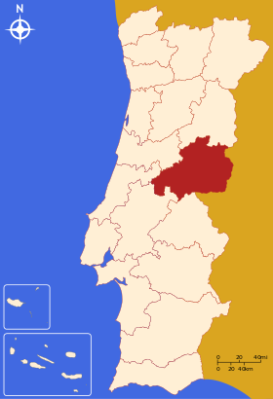

Figure 1. District of Castelo Branco in Portugal

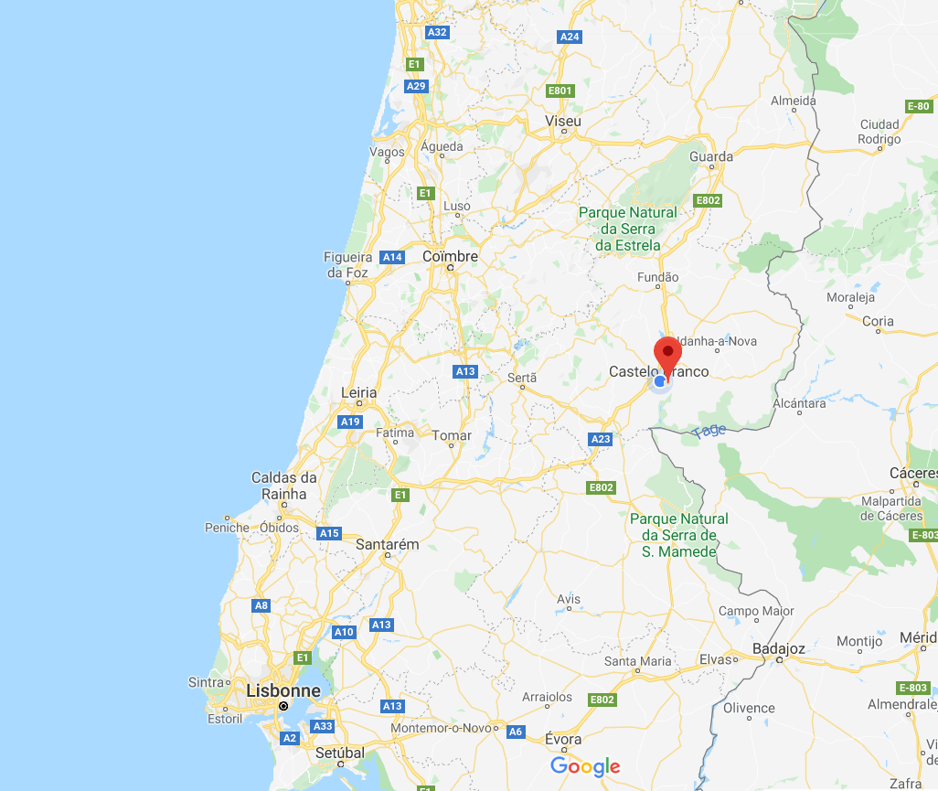

Figure 2. Position of the city of Castelo Branco

In terms of area, it is the 4th largest district in Portugal with 6,675 km² and has 179 038 inhabitants out of the 10,276,617 million that make up the whole of Portugal. Castelo Branco has approximately 56 000 inhabitants.

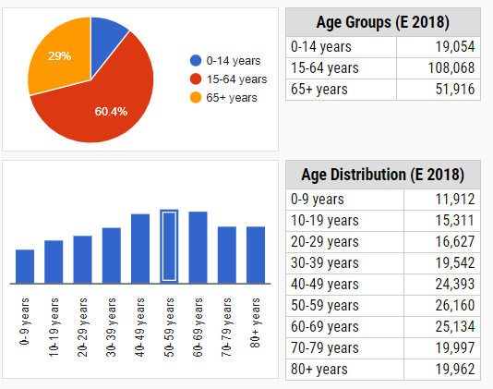

Figure 3. Statistics of the population of Castelo Branco district compared to its age group

According to the National Institute of Statistics in Portugal, the district of Castelo Branco is made up mainly of people between 50 and 59 years old. We can see that the share of children between 0 and 14 years old is only 10.6%. We can therefore fear depopulation in the years to come. According to the same study, we study a decrease of 1.17% per year on average since 2011.

Failure to retain qualified human capital in the municipality has contributed to a decline in GDP per capita. An example is the difficulty of filling vacancies for medical specialties in hospitals. Skilled young people attending higher education outside the district have a relatively low return rate, eventually settling in large urban centres. Emigration to foreign countries also contributes to the inability to increase the local labour force, reaching several fronts, both generational and skilled. This departure of people is partially offset by the entry of students to the IPCB (polytechnic institute of Castelo Branco). It’s in this institute that I carried out my internship. I will present this in more detail, explaining its creation, its usefulness and its organization.

# School presentation

## Polytechnic institute of Castelo Branco

The Polytechnic Institute of Castelo Branco (IPCB) is a public institution of higher education which began its activity in 1980 and which constitutes a reference of confidence in the high-level qualification of citizens, in the production and dissemination of knowledge, as well as the cultural, artistic, technological and scientific training of its students in an international frame of reference. It offers a wide range of training in its six higher schools:

Figure 4. The size higher schools of IPCB

The date of creation and the types of schools of the institute is quite representative of the sector of activity of the region and its demand. For example, the Castelo Branco area is a rich area for agriculture and has all the infrastructure required for the development of this activity. So, it makes sense to create a school in this area. As explained in the previous point, the creation of an institute in the city of Castelo Branco represents a strategic choice for the city and the region because it would educate young people and promote employment in local businesses. This would thus make it possible to overcome the problem of depopulation. The students come mainly from the region. The total number of students in the university is 4000.

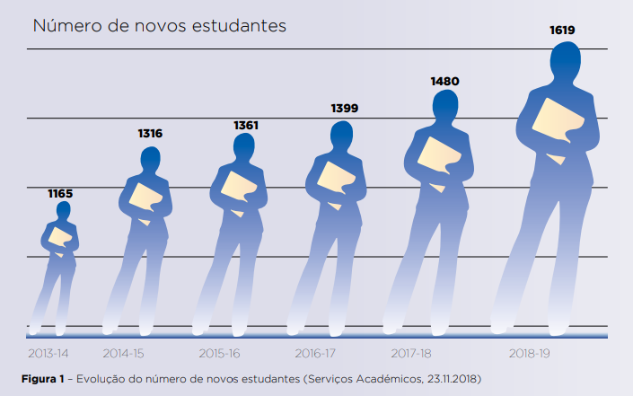

Figure 5. Evolution of number of new students in IPCB

From the analysis of the total number of students to join the IPCB in the last 6 years considering all levels of training and all admission regimes for degrees, there is an increase of 39.0%. Figure 5 shows the evolution the number of new students, including 87 students enrolled in three distance learning postgraduate courses.

IPCB is active institution, with people capable of promoting and strengthening internal and external, local and regional, national and international synergies, and committed to cooperating with local political power, social and cultural institutions, commercial organizations and educational institutions, by promoting the scientific, technical, artistic, cultural and civic participation of young people and adults looking for the institution.

The IPCB is determined to evolve towards an institution better prepared to compete and win in a constantly changing world, becoming a stronger and more interventionist institution and making a decisive contribution to the social, cultural and economic development of the region and the country.

Internationally, the IPCB has carried out an interesting route being necessary reinforce the adoption of a strategy consistent with the increasing globalization of education and research and innovation, establishing agreements with foreign HEIs, both in the European context, as well as in Lusophone or Ibero-American. These agreements usually generate important opportunities for cooperation both at the level of education and research. The internationalization of teachers, non-teachers and students, in all areas, is equally important importance, and all initiatives promoting this same internationalization. As part of fundraising international students, a strategy line with that of the region will favour the IPCB's identity and renew that of the region, contributing to economic, social and cultural development.

The values of the IPCB are:

* Quality of services provided and reinforcement of the institutional image.
* Rigor and transparency in strategic and management options.
* Effective communication with stakeholders.
* Valuing people with recognition and promotion of merit.
* Cooperation and commitment to society.
* Encouraging creativity, entrepreneurship and innovation.
* Openness to the world.

## School of technology of Castelo Branco

I realize my internship on ESTCB (Technology school). The campus occupies a total area of ​​43,000 m2, with its built area divided into 4 blocks with different heights and interconnected, forming a harmonious ensemble and inserted in the surrounding landscape. To support sports activities, the School has a multisport field that is located next to the leisure area of ​​Castelo Branco. She is composed to 71 teachers divide on 19 formation.

Figure 6. All the formation available on ESTCB

I placed myself as a computer scientist, but I worked with people from electrical and telecommunication engineering.

## Mission context on school

Certain companies when they encounter problems in a sector of activity different from their own, can ask the school for help in responding. They therefore express their need and the school studies whether it is feasible for them or not, considering their human, economic and logistical resources. If the solution is workable, then the school and the company set up specifications about the project. The benefit for the company is to benefit from the know-how of the school to meet their needs and for the school, it’s to apply their skills to the service of companies and to be able to benefit from a partnership thereafter. The solution can be made by students or teacher.

This in this context that I realized my mission. I had the two missions, one directly for a company and the other for a student project. Both solutions need informatic skills, so they needed my help to realize this. I worked in the telecommunication domain, so all projects have, at least, a part of communication. That is the case of two companies, R.D.R and bee’s companies.

The main mission was with students’ teams. It’s an IoT project with bee monitoring. I will explain in detail the mission on next part. The team is composed by 4 peoples.

The first people it’s mister Torres, the project advisor and my internship tutor. He is teacher on telecommunication domain on ESTCB. The second is Mr Formiga, it’s a student on electric and telecommunication degree, the founder of the project and he take care about software and hardware parts. Despite, he also knows web technologies. The third people are Mrs Cosme, she is on school of applied arts, she works on advertising/ marketing. My role in this project is to develop the web-based solution part. But I also worked on little part of electronical part.

For the other project, I worked with people on the “client” company, R.D.R, and with people on school. R.D.R (Reception, Dismantling and Recycling) is a company who receive old or broke vehicles and he’s dismantling this to store pieces of cars for after reselling them. The first need of this client is to have informatic system of storage and website to see all pieces in this storage. The team was composed by:

* Mr Torres: project advisor.
* Mr Formiga: software developer.
* Mr Fernandes: project assistant in R.D.R project, also teacher in automatism on ESTCB.
* Mr Lucas: director of R.D.R.
* Me, Julien Juncker: software developer and web developer.

On next part, I will present more in detail the mission I realized during this internship.

# Mission – Bee project

## Abstract of the bee project mission

The internet of things plays a key role in sustainability. The IoT (internet of things) refers to system who the physical objects are linked to internet. It means a system who allows you to create and transfer data to create value for users through different services. This system is also useful in environment who present risk for humans, in most cases, to avoid the human’s intervention. It’s the case for beekeepers. The accurate knowledge of stocked information’s is therefore essential for study the state of hive and the cost-effectiveness to beekeepers and a way to have a remote view this information about hive will allows beekeepers to save time, money and be more secure. We will present an IoT system on bee’s environment to avoid beekeeper’s intervention and improve the effectiveness decisions made concerning bee’s production of honey.

## Introduction of bee project

In 2015, Portugal count 626 399 hives all around his territory as you can see on figure 8. Beekeeping is encouraged in Portugal due to its climate very suitable, its vegetation and its relief. The beekeeper contributes to the maintenance of plant biodiversity by ensuring sound management of bee populations.

|  |  |  |  |  |
| --- | --- | --- | --- | --- |
|  | 2013 | 2015 | Variation (n° and %) | |
| Number of beekeepers | 16 774 | 10 698 | -6 076 | 36 % |
| Number of places of hives | 40 176 | 33 876 | 6 300 | 19 % |
| Number of hives | 566 793 | 626 399 | 59 606 | 10 % |
| Total of places of hives / beekeepers | 2 | 3 |  | |
| Total of hives / beekeepers | 34 | 59 |

Figure 7. Table of the general characterization of beekeeping in Portugal in 2013 and 2015

When we talk about the work of beekeepers, we think about the sale of honey. But it’s not just that, in fact, they also need to monitor and maintain hive. If hives are not maintained, bees could go in another place more comfortable.

For respond to the need of monitoring, we can use IoT system. This allow users to observe remotely bee colonies. They can apprehend the internal organization of the hive without opening, also taking advantage of many sensors are more performant than our senses (For example, thermometers, balance, humidity…)

If many sensors are currently relevant for scientific studies, few are used by beekeepers for colony management. Only automated scales are routinely used by beekeepers to quantify daily changes in hive weight due to net honey storage, and for example manage their transhumance. Technology for environmental monitoring, breeding or entertainment Monitoring on a continuous basis physical variables of honeybee colonies (e.g. temperature, humidity, weight, vibrations, and forager traffic) is becoming feasible, since the cost and size of electronic sensors decrease and their precision and capacity increase.

In research, the study of bees is also interested because with the different sensors, we can upgrade the understanding of unknown phenomena and propose solution to have well protection of bees.

For the first solution for the client, we just choose to use 3 sensors on the hive, temperature, humidity and weight sensors. We store this information on database, and we retrieve this on website, the user can see temperature, humidity and weight chart and filtered this by location, date and user (because hive can be the property to multiple user on same area).

Answering this need, we propose an IoT system in hives to allow users to watch remotely state of hives using sensors and manipulate this information in web-based solution. First, we are going to present the IoT part. After that, we present the web-based solution. We will discuss the choices we have chosen for the global solution.

## IoT system in bee project

According to ITU (international telecommunication union), the IoT has been defined as *“a global infrastructure for the information society, enabling advanced services by interconnecting (physical and virtual) things based on existing and evolving interoperable information and communication technologies”.* IoT is composed around 5 essentials components*:*

* The objects (sensors).
* The network (connectivity).
* The data.
* The information.
* The operating applications.

You can see all steps on figure 8.

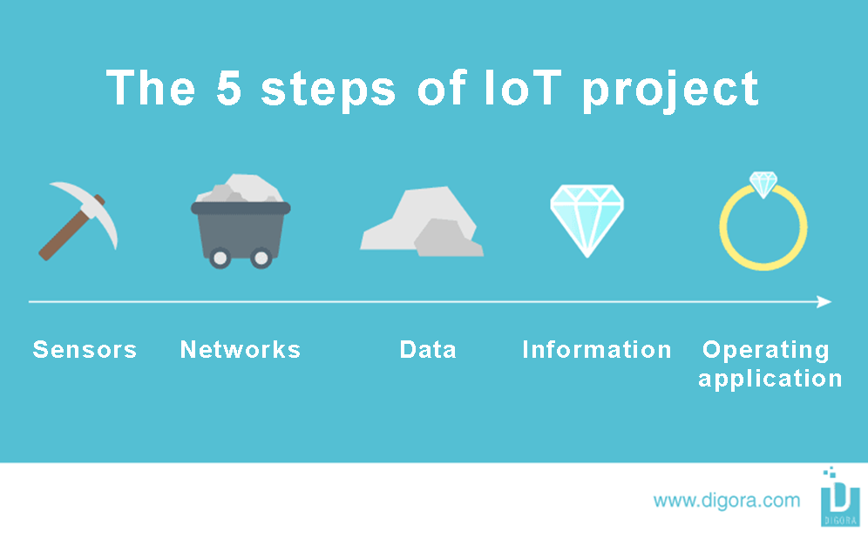

Figure 8. The 5 main steps of IoT project

For each part, we need to choose one component or technology the most efficient depending about the environment or the condition.

### The object

The object is all the equipment who could generate exploiting data and value creators for users. Objects are composed by:

* Passive elements: sensors.
* Active elements: component enabling data enrichment processing and data transmission.

In our case, passive elements will be humidity and temperature sensors with balance. The active element will be the electronic programmable card we use to control the sensors. We need a card with network card to allow the transmission of value to the web solution. So, for this choose, we have 3 components:

|  |  |  |  |
| --- | --- | --- | --- |
|  | Arduino UNO card with WIFI module | Node MCU (ESP8266) | Raspberry pi 3 B+ |
| Picture | Résultat de recherche d'images pour "arduino uno" | Résultat de recherche d'images pour "arduino with wifi module" | Résultat de recherche d'images pour "raspberry pi 3" |
| Cost | 10 – 20 euros + 5 euros for wifi module | 5 – 10 euros | 40 - 50 euros |
| Advantages | . IDE to program sensors in C language.  . Pins to connect multiple sensors  . Many documentation  . Durable system  . Comptability with analogic sensor | . Based on arduino Uno (same advantages)  . Wifi module installed on board  . Very tiny  . Low cost | . Very powerfull  . OS on board  . Possibility to program in multiple language  . Many ports  . Wifi and bluethooth avaibility |
| Disadvantages | . We need to add external module for WIFI  . Bigger and more expensive than ESP8266 | . A little bit fragile than other components | . Not comptatible with analogic sensor (we need to convert value with i2c bus)  . Too expensive than other components  . Bigger than other components  . Need more power than other components |

Figure 9. Comparison with different programming card

In the figure 9, we can see the esp8266 it’s the better solution for our solution because we can program sensors using Arduino IDE and we have Wi-Fi availability to send value to network part. The size is good to keep all the object part in a small box.

For passive parts, we need to compare all sensors we want to use for the solution. For the temperature sensor:

|  |  |  |  |
| --- | --- | --- | --- |
|  | DHT 11 | LM35DZ, LM335, LM34 | BMP180 |
| Picture | DHT11 Temperature and Humidity Sensor | LM35DZ LM35 Temperature Sensor | BMP180 barometric pressure sensor |
| Cost | 2 - 3 euros | 2 - 3 euros | 2 – 3 euros |
| Range of sensor | 0 to 50 ºC +/-2 ºC | -55 to 150ºC | 0 to 65ºC |
| Advantages | . Very easy to use  . Can measure temperature and humidity  . Good precision  . Low cost | . Very easy to use  . You don’t need library to read temperature  . Good precision  . Low cost | . Very easy to use  . Good precision  . Low cost  . Can measure pressure, temperature, estimate altitude |
| Disadvantages | . If the sensor is broken, you cannot measure humidity and temperature | . He just read temperature | . He cannot read humidity |

Figure 10. Comparison with different temperature sensors

As we can see on figure 10, DHT11 sensor can read humidity and temperature and he have the same advantage than another sensor. So, we can choose this sensor.

In final step, we just need to choose the balance for the weight sensor. When you want to have the weight measure, you need to have:

* HX711 on breakout board - This microchip is specially made for amplifying the signals from load cells and reporting them to another microcontroller. The load cells plug into this board, and this board tells the Arduino what the load cells measure.
* 50kg load cells (x4) - Load cells are specially shaped metal parts that have strain gauges glue to them. When the metal part bends, the resistance of the load cell changes (the HX711 measures this small change in resistance accurately).

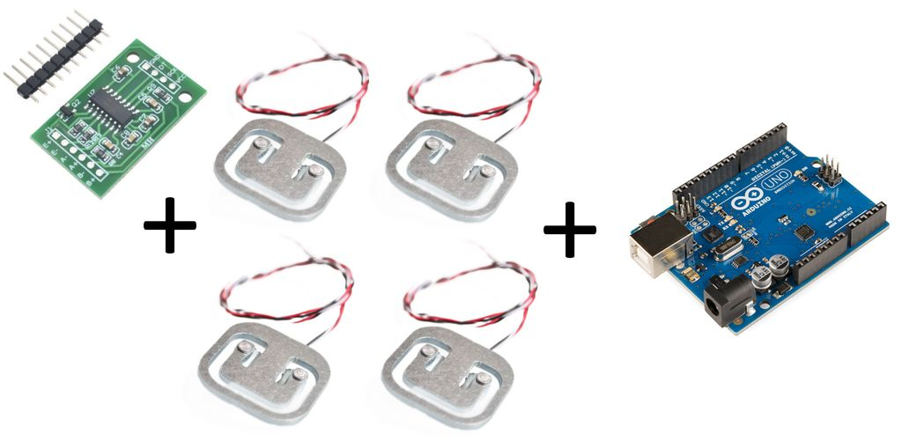

Figure 11. Weight sensor with Arduino/esp8266 component

For the HX711, all other alternative is based on his system. So, apart her size, the price and the connectivity, we don’t have changes. We choose the default HX711 sensor because it’s good for our need (we can see on figure 11).

Now we have all the object part:

* ESP8266 as programming card
* DHT 11 sensor as temperature and humidity sensors
* HX711 with 4 * 50kg load cells for weight sensors

After that, we need to find a solution to communicate with the web solution to store data in specific data storage.

### Networks

The networks are one of the most important parts of IoT project, they need to respond one usual criteria, The coverage of the area of use of objects. In our case, we just need to communicate between area of hives and beekeeping offices and beekeeping offices to school office (because the storage system will be on school) with Wi-Fi signal. Generally, the constraint he has in IoT network parts is: Will the object have continuous power source? That is the condition for:

* The architecture of the solution
* The conception of the object
* The life cycle of the solution

The hives don’t have power source, so we need to find a solution for this constraint. The better solution we have is to use battery for supplying each programming card. This reduces the life cycle of the solution because to beekeeper need to change battery when is empty. For the conception of the object, we plan a space for battery on the box. We need a simple access to the battery to make the battery change more comfortable. To finish, the architecture will be different than we have power source near the hives because if you have power source, we can put router and just communicate in Wi-Fi between esp8266 and router. So, we need to adapt networks architecture.

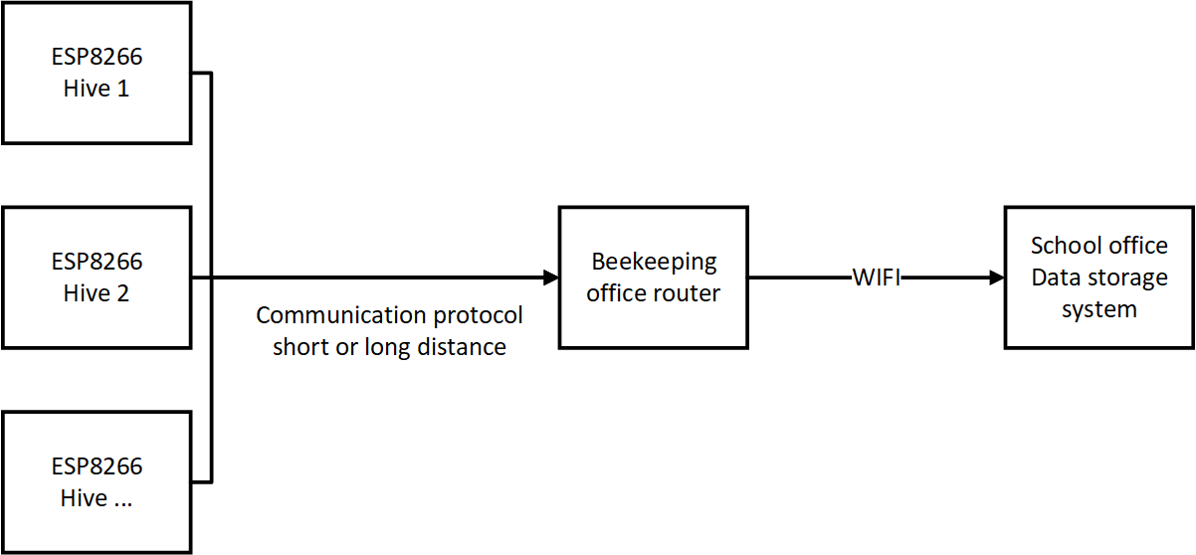

Figure 12. Bee project network structure

As we can see on figure 6, we have esp8266 on each hives, need to communicate with beekeeping office router to send data in Wi-Fi to school office data storage system. We can have 2 types of communications for the communication between hives and beekeeping office:

* A short distance communication: If the Beekeeping office is close to the hives to communicate with Wi-Fi signal.
* A long-distance communication: If the Beekeeping office is far from the hives to communicate with Wi-Fi signal.

The problem with long distance communication that this method is more expensive than just use Wi-Fi signal because we need other module to communicate with other protocol. We will therefore plan to type of architecture that will depend on environment of beekeeping.

#### *Short distance plan*

In this use case, we are going to use the Wi-Fi module to communicate between router. The problem is we are not sure that Wi-Fi coverage is available in all the hives area.

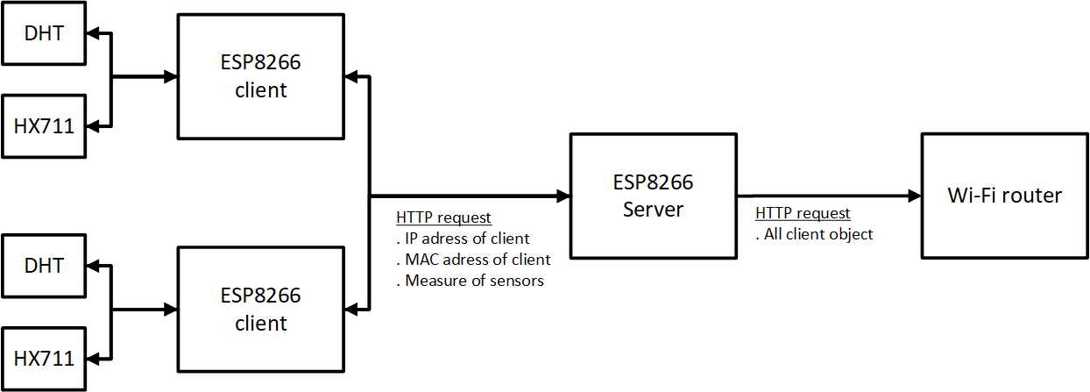

Figure 13. Networks architecture for short distance

As we can see on figure 13, we have multiple esp8266 client who are linked to sensors. The client take measure in regular period and send all this information on HTTP (Hypertext Transfer Protocol) request to esp8266 server. He stores all these elements in class and send in regular interval this data to router with also HTTP request.

#### Long distance plan

In the long-distance communication, we need to find a protocol who allow a communication as far as possible. In IoT, we use generally the LPWAN (low-power wide-area network). The most famous network technologies we use are:

* SIGFOX
* LoRaWAN (Low Range Wide Area Network)

Common points of this technologies:

* They can just send little message (12 bytes for SIGFOX and 24 bytes for LoRaWAN)
* They have a good penetration capacity on buildings

|  |  |  |
| --- | --- | --- |
|  | LoRaWAN | SIGFOX |
| Advantages | . Low energy  . Long-range  . Standard technology (can be quickly deployed)  . Can send bigger message than SIGFOX | . Low energy  . Long-range  . Single operator (SIGFOW operator) |
| Disadvantages | . Data length | . Data length |

Figure 14. Comparison between LoRaWAN and SIGFOX networks

For the network technology, we prefer to use LoRaWAN network because we can send bigger message than SIGFOX and she don’t have disadvantages compared to SIGFOX.

LoRaWAN network architecture is typically constructed in a star-of-stars topology in which gateways is a transparent bridge relaying messages between end-devices and a central network server in the backend. Gateways are connected to the network server via standard IP connections while end-devices use single-hop wireless communication to one or many gateways.

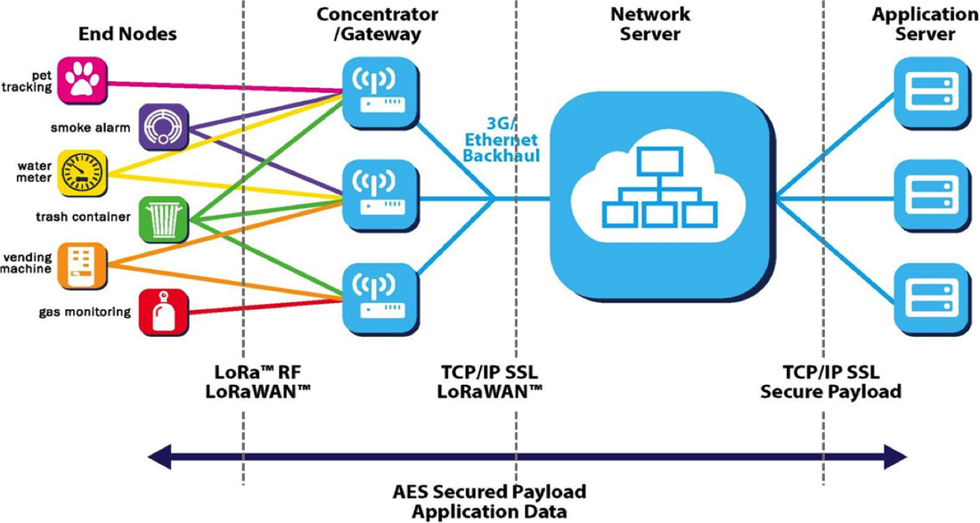

Figure 15. LoRaWAN architecture

The figure 15 present the architecture with LoRaWAN. As we can see, this technology proposes a complete network system. But it also possible to just use LoRa technology. The difference is:

* **LoRa** contains only the link layer protocol and is perfect to be used in P2P communications between nodes. LoRa modules are a little cheaper that the LoRaWAN ones.
* **LoRaWAN** includes the network layer too so it is possible to send the information to any Base Station already connected to a Cloud platform. LoRaWAN modules may work in different frequencies by just connecting the right antenna to its socket.

We are just interested about a long communication we don’t need to have network layer with LoRaWAN. So, it’s better to use just LoRa technology with peer to peer communication.

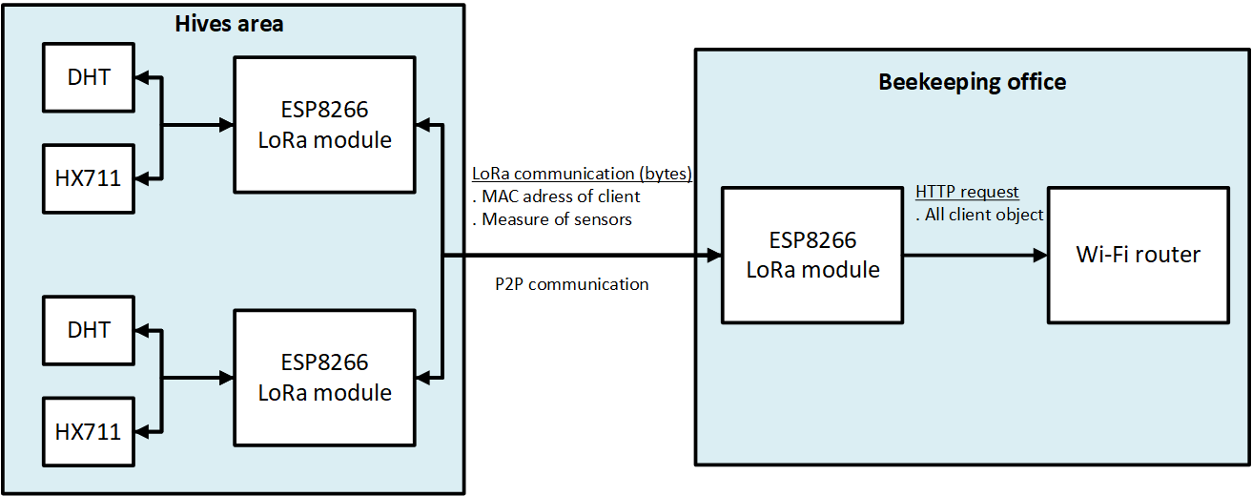

Figure 16. Network architecture for long distance

We can see the architecture for long distance in the figure 15. All esp8266 are equipped with LoRa module and they communicate between each esp8266 on hives and esp8266 on Beekeeping office, like peer to peer communication.

For conclude the network part of bee project, we have 2 solutions depending about the environment of beekeeping

* Long distance between hives and beekeeping office: we use LoRa technology
* Short distance between hives and beekeeping office: we use HTTP

With this solution, we can receive data of object part and transfer to data part. We will see how to store this information.

### Data

In IoT project, data are our diamond. These are mainly the raw elements that we have collected from objects. For create value for users of these data, we absolutely need to store, record and save in data storage with a great structure to improve performance of IoT operating services.

To do this we have the choice to use between **database** or a **simple text file storage** like a JSON, csv or txt file. Finally, we chose Database system because he has as most important advantages:

* Ability to store large amounts of information
* Sharing information
* Having quick access to information
* Great structure of data

So, In our case it’s the better solution. The choice of the database will depend about the choice of operating application. For example, we couldn’t choose same database if we use web solution with webserver or an application/services. So, we will choose database in operating application part.

### Information

We can define information like a cut diamond. It’s the result of treated data, correlated and analysed. Like data part, this information needs to be store, record and save in database. For example, in our case the measure of temperature can be transformed to an alert, if temperature is too could or too high, an alert appears in operating application. All the information we want for the first solution is:

Figure 17. Table of all necessary information for first solution of bee project

This information will allow us to generate temperature and weight chart and alert with temperature and weight measure when threshold is exceeded. The user can also filter chart with date, location of hives, areas of hives and value interval to have a detail view.

Now, we know what we want to propose as clients for first solution, we need to find a way to present this information.

### Operating application

The Operating application is usually Human Machine Interfaces (HMI) when we can retrieve data in form of dashboard. We can imagine diamond mounted in jewellery. We can find charts, data table, reports…

For create this application we need to choose a method like:

* A website
* An application/service

The only constraint we have is to use a PC with Linux OS installed. In the need, we want a operating application with:

* User authentication
* Data retrieving with charts and alerts
* Possibility to filter chart
* Possibility to change alert threshold
* The charts need to be in real time (don’t need to actualize)
* We need an access everywhere

With this need, it’s better to choose a website than application/service because for the question of access is the best solution. With a website you don’t need to install software in each PC to access on dashboard. And it’s also possible to realize all the requirements. So, the solution is to install webserver on Linux operating system on the computer.

Generally, when we want a web-based solution, we do the choice to use a web stack. It’s a collection of software or technologies that are used to build a web application. It provides a link between the website and the database and it takes very little time to get up and running. He gives you the best web structure to develop web solution.

He exists 2 famous web stacks in Linux:

* LAMP:
  + Linux: Operating system
  + Apache: Webserver
  + MySQL: Data persistence
  + PHP: programming language
* MEAN:
  + MongoDB: Data persistence
  + Express.js: server-side application framework
  + Angular.js: client-side application framework
  + Node.js: server-side environment

|  |  |  |
| --- | --- | --- |
|  | LAMP | MEAN |
| Advantages | . The most used web stack on the world  . Libraries, add-ons, endless modules available to adapt your solution to your need  . open source  . Big community  . MySQL is a very scalable and reliable solution  . PHP is very fast and integrates well with the rest of the stack  . You can control the server and decide which versions and software you install | . Don’t depend of operating system  . JS faster to learn than PHP  . MongoDB faster than MySQL to execute a lot of read request  . Angular is very well maintained by Google  . Easier to build mobile or desktop apps |
| Disadvantages | . We need to be careful to use good practice (problem of performance, security…)  . The relational database like are less scalable than NoSQL like MongoDB | . More recent than LAMP (less community, less libraries, many new versions…)  . Harder to maintain a clean code base and follow best practices as app grows |

Figure 18. Comparison between LAMP and MEAN web stack

We also have other criteria to present, it’s the familiarity with the language. In our case, developers are more familiar to LAMP web stack. We decide to use LAMP because is the technology the most secure to keep a proper functioning and code clean. We can benefit of a large community to help us for the development of the web solution.

We present the 5 main steps of the bee IoT project with the choice of solution for each step. Now, we are going to present in detail the solution of this project with the prototype.

## Presentation of bee solution

#### Presentation of electronic parts

In the electronic parts, we work with ESP with “client” “server” architecture. To understand how this architecture works, here is a flowchart to explain this.

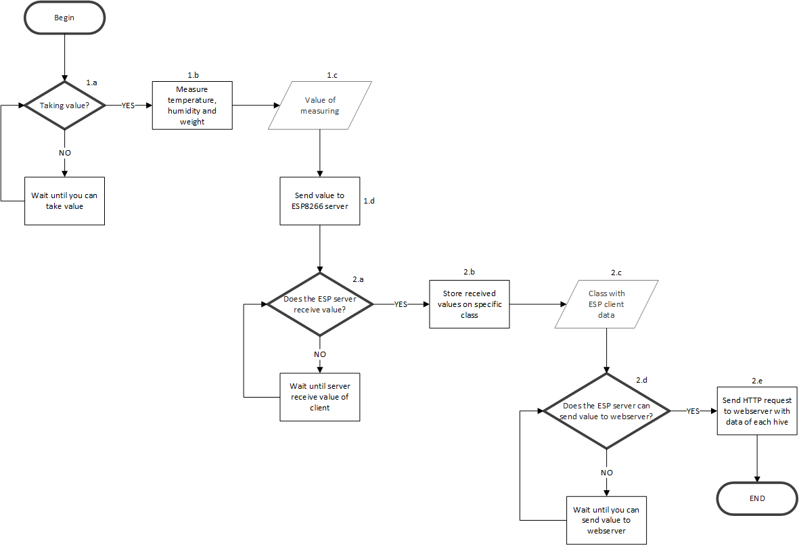

Figure 19. Flowchart electronic part of bee project solution

1. **On each ESP “client” (ESP on hive)**
   1. We need to measure and send value each 5 seconds. So, we until this timer is achieved.
   2. We use sensors to measure temperature, humidity and weight.
   3. Our data it’s the result of measures.
   4. We send the result to ESP server (ESP on beekeeping office).
2. On ESP “server” (ESP on beekeeping office)
   1. We wait until you receive value of client.
   2. When we receive value, we store this information on class. An object will be composed by the Mac address, the IP and the measure of one ESP client.
   3. Our data it’s every object of ESP client class (ESP client information).
   4. Every 10 seconds the ESP server send this information to the Webserver. We need to wait until this timer is achieved.
   5. We transform each object information on HTTP request, and we send to the webserver.

The only difference between short and long-distance solution is ESP client send information to ESP server with HTTP request on short distance solution. In the long-distance solution, we communicate with LoRa system.

The “client” ESP are linked to sensors with electronical circuits. So, the Node MCU board (ESP8266 board) are wired like this:

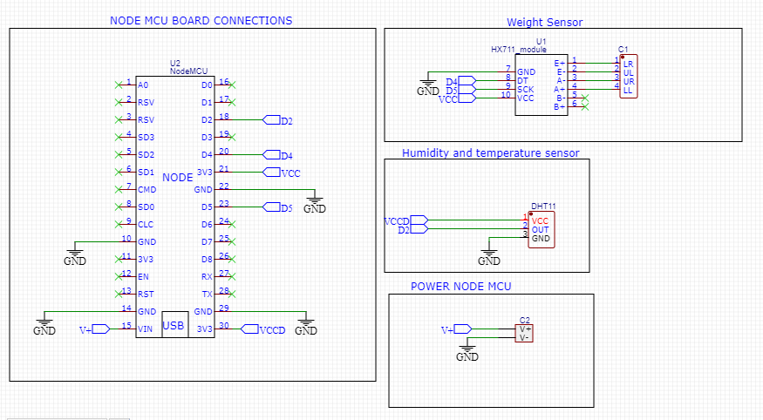

Figure 20. Electronic circuit of esp8266 board with sensors

As we can see on figure 20, sensors are wired in digital pins of ESP board. We can wire all sensors without extension card.

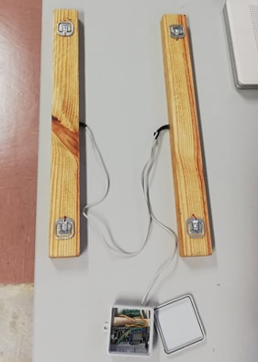

Figure 21. Bee project electronic prototype

#### Presentation of database part

In database part, we have the reception of ESP information and transmission to database. This part work like figure 22.

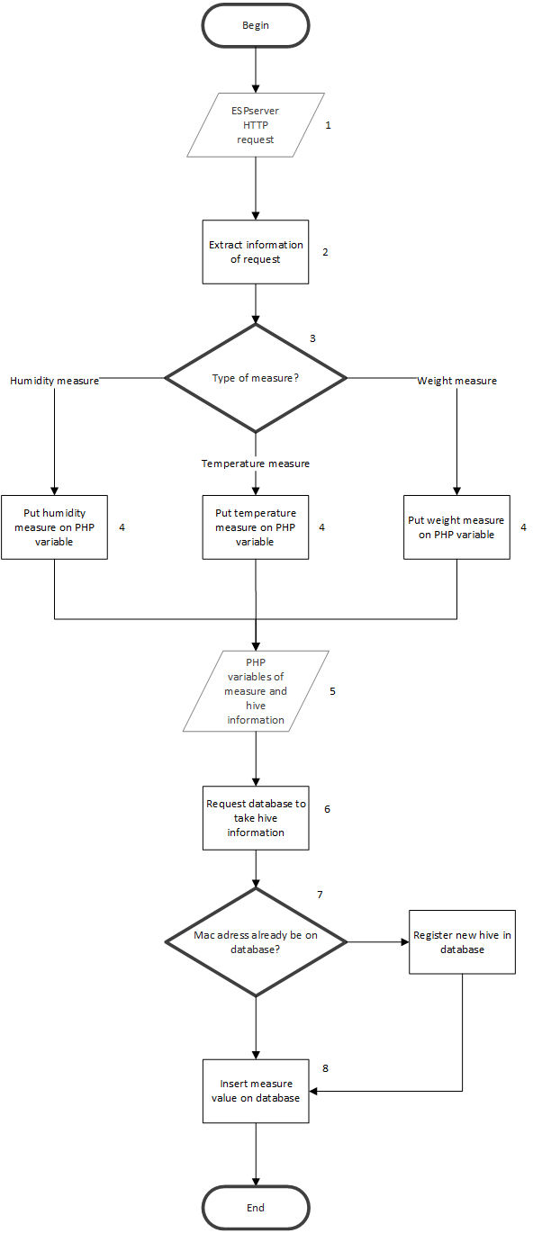

Figure 22. Flowchart of database algorithm in webserver

1. The data of entry is the HTTP query who receive of ESP.
2. We extract information present on query.
3. Divide information by the type of measure.
4. Put result of measure, current datetime and hive ID on php variable.
5. The data is all the variable on step 4.
6. Do a SQL request to have hive information present in database.
7. Iterate all the mac address (ID) present in database to know if you already have hive information. If not, register new hive.
8. Insert all the measure on specific table (weight in weight table, temperature in temperature table …) with date of measure taken and ID of hive.

All this part is contained on webserver structure. When we receive HTTP request, the webserver can understand this and execute the specific action. In our case, we put “esp_measure” as header of request and the PHP code decrypt and call specific PHP function.

Figure 23. Database structure of bee project

On figure 23, you can see the structure of database. Each sensor measure has specific table with foreign key to the ID of hive. We have a table for user and for hive. Hive has a foreign key to user ID.

#### Presentation of website part

On the website part, we will talk about the algorithm and website architecture. We also present the render of the website.

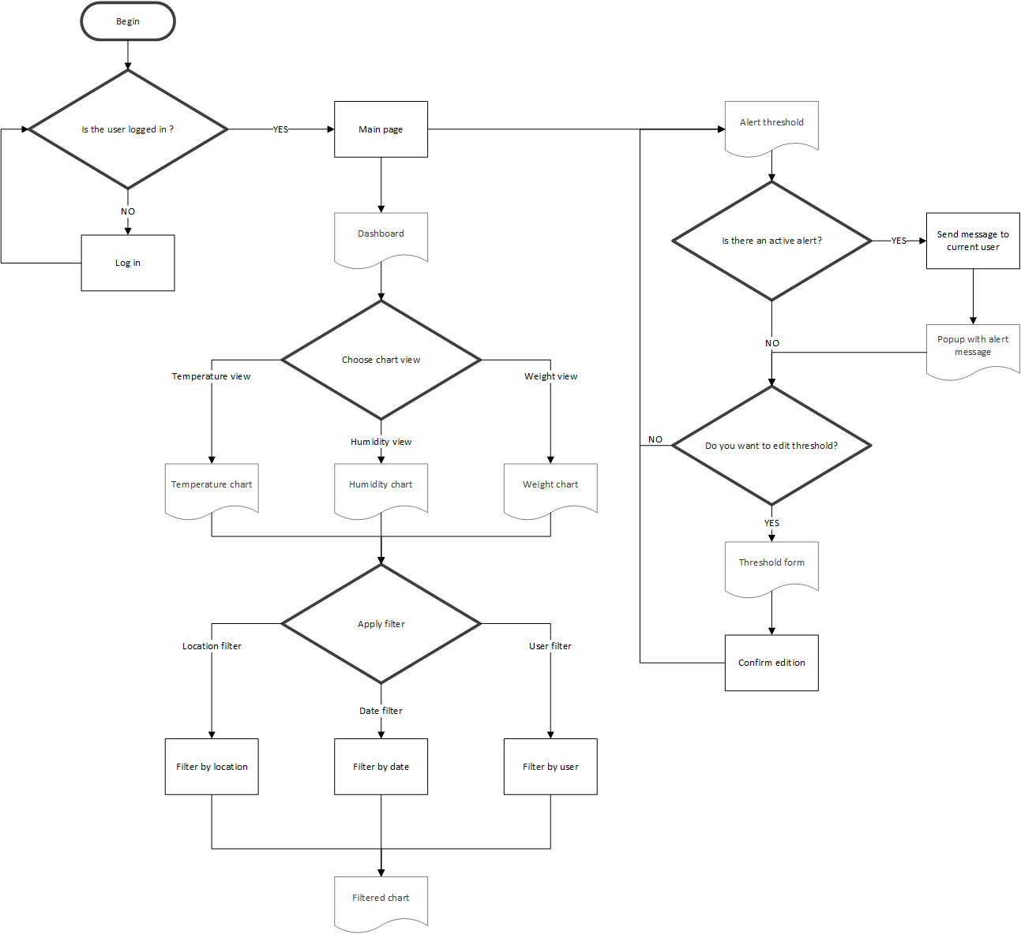

Figure 24. Flowchart of website algorithm in webserver

1. Check if the user is already logged in. If not, redirect it to login page.
2. In the Main page, we have dashboard and alert threshold.
3. In the chart view, by default, temperature will be load on dashboard. If we want to change, we need to click on button of specific chart.
4. You can apply filter chart by location, date and user (maybe some hive area belongs to specific user).
5. In threshold view, you will have all configuration of alert threshold.
6. If he has active alert, a popup will appear to alert you.
7. You can edit threshold on specific threshold form.
8. When it’s finish, you can click on “confirm edition” button.

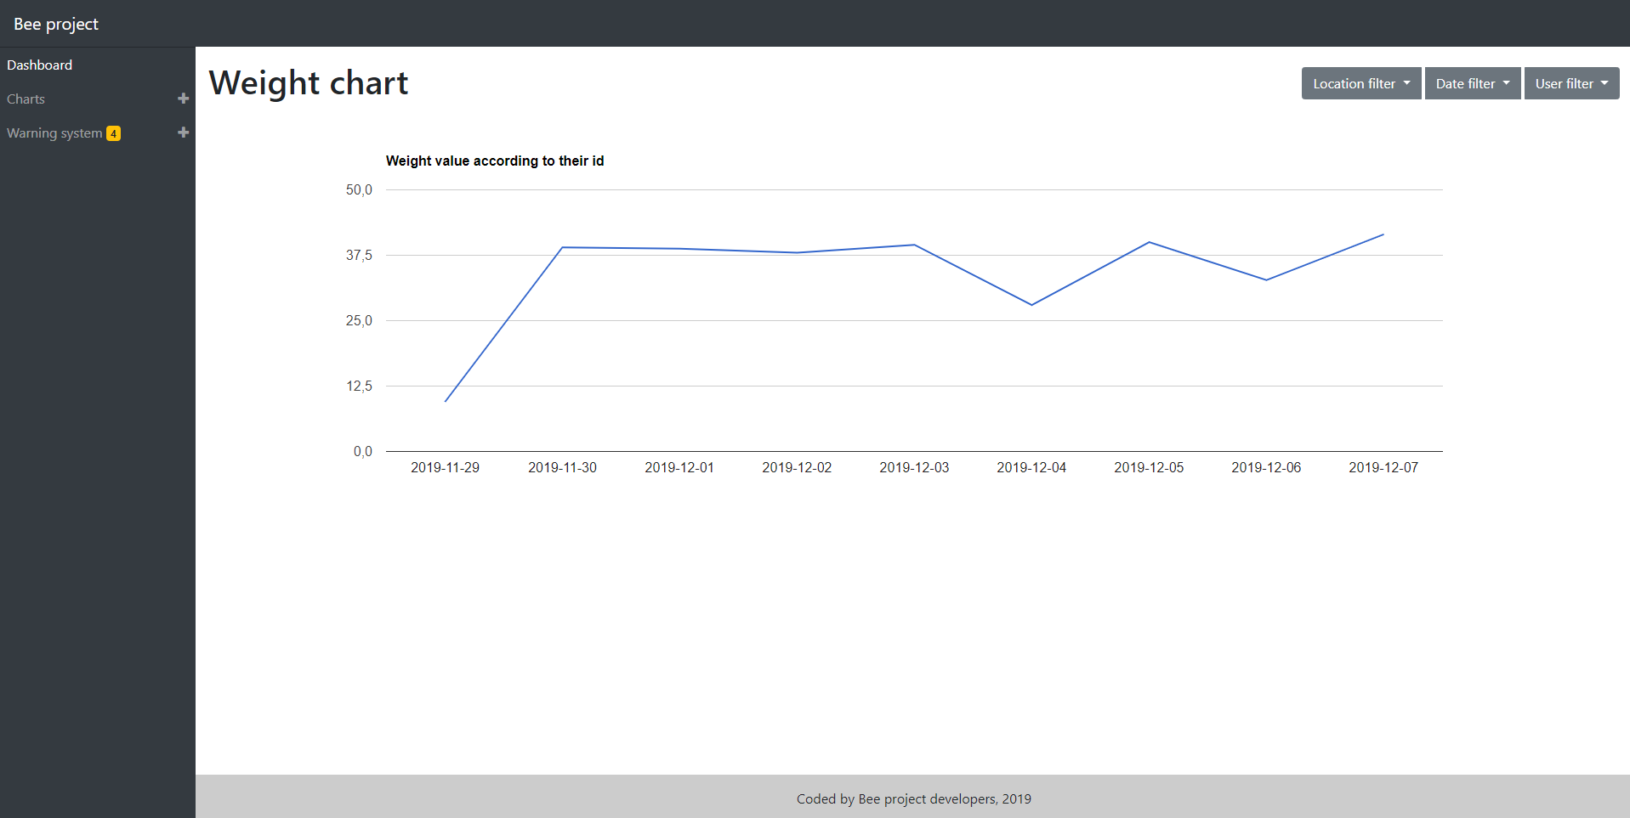

Figure 25 . Bee Project website

# Mission – R.D.R Project

I also worked on other mission during this internship in society called R.D.R (Reception, Dismantling and Recycling). It’s a company who receive old or broke vehicles and he’s dismantling this to store pieces of cars for after reselling them. The first need of this client is to have informatic system of storage and website to see all pieces in this storage. In this part, I just will explain quickly the need and solution.

## Abstract of R.D.R mission

The disassembly of end-of-life vehicles (ELVs) plays a key role in sustainability. It enables the recycling of materials, the reuse of functioning components and the separation of harmful substances. Major challenges for these companies result from the enormous variety of components to be disassembled and stored, and uncertainty at ELVs’ supply and components demand. The accurate knowledge of stocked components is therefore essential for the economic disassembly of ELVs. This paper presents a web-based Decision Support System (DSS) to assist the disassembly of ELVs and improve the eﬀectiveness of decisions made concerning components disassemble and storage.

## Web solution in R.D.R mission

The web solution is included in storage process. The database allows to store and retrieve information about speciﬁc component and storage on the warehouse. The importance to use web solution to manage stock is to automate all the actions with the inventory. This technology allows the user to see or manipulate remotely materials. This saves time and money.

To meet this need, we can use Database (which stores data with a good structure), and Website (To have an interface to see or manipulate items). To access remotely to Website and do more complete functionalities, we need to use Webserver like Apache2 and set it up on a server. Plan a system to store faster a new item in database, is essential, this can be done using for example, RFID system where each card contains a speciﬁc item. We can imagine a system that when a card has passed in RFID reader, we store automatically data in database. An authentication system with rights is also present on the website because, in order to allow a client to see components stock of the company, we need disallow all the modiﬁcation features. The ﬁgure 26present the global architecture of R.D.R. web solution, with communication to each part.

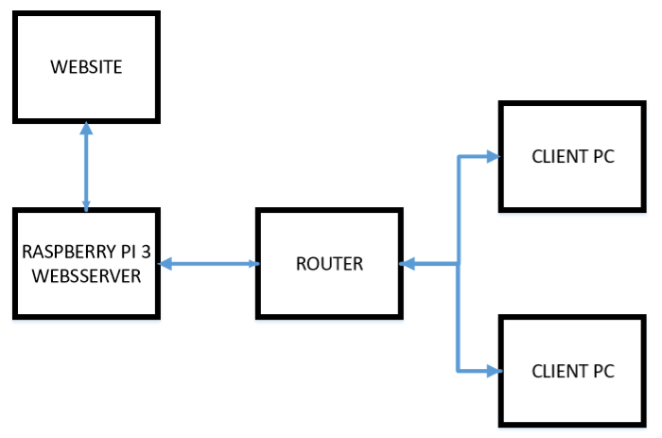

Figure 26. R.D.R web solution architecture

### Website of R.D.R Project

The need that we can ﬁnd for the use of a website is to have a remote view to data stored in a database. We can manipulate this. The website that we will present permit an administrator user to:

* Have a quick visual about the items.
* Have the possibility to manipulate it.
* Have an authentication system on website for more security.

The default user just can have a quick visual about the components in warehouse. For a quickly access to speciﬁc information that we want, we have planned a ﬁltering and search system. The manipulation of items can be editing, adding, removing items. The authentication system permits to give speciﬁc rights to each user groups. For example, default client cannot manipulate items directly. For each modiﬁcation, we need a conﬁrmation of administrator. You can see all features of R.D.R website on ﬁgure 27.

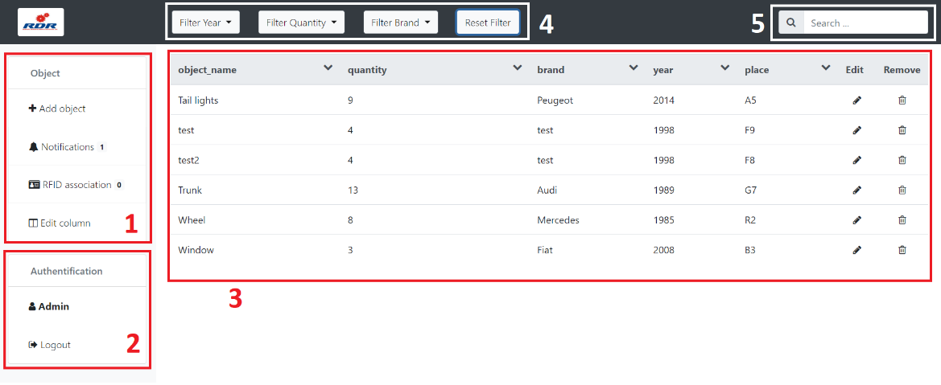

Figure 27. R.D.R website

1. Object part: We can add an object, conﬁrm client modiﬁcation request in ’notiﬁcation’, associate RFID to item and edit column in table.
2. Authentication part: We can see connected user and disconnect this current user.
3. Table view: We can see all information about items or edit or remove it.
4. Filtering part: We can ﬁlter table with speciﬁc year, quantity or brand. Also, we can ﬁlter in a time interval or quantity.
5. Search bar: We can search speciﬁc item.

### RFID system in R.D.R Project

To respond to the need of product storage, we need to ﬁnd the better solution to add a new component in database. The goal is to ﬁnd a quick and ergonomic solution to increase the number of one component. If we don’t use speciﬁc system to add an element, it will be so long because we need to write a SQL request or to ﬁll a form on a website. If we just need to add one element, it’s a better solution. However, when we want to add many elements, we will lose time. we can use for example:

* Program with a graphical interface.
* Scanner with bar code or QR code.
* RFID system with card reader.

The problem with the program is the need of a computer and it is not the fastest method. The scanner is faster but in a place with some dust like a factory, this may not be detected by the scanner. So, the better solution is to use RFID system, because it is contactless and fast. More in detail, the RFID system works with electronic chips who included identiﬁcation number and speciﬁc information. When the user swipes RFID tag, we can retrieve information with the electronic signals. The goal is to associate each RFID card to speciﬁc item. To achieve this, we need to have programming card like ESP8266. With this card, we have WIFI communication and it we allow to programming RFID reader. The ESP8266 is a programming card where we can program and upload code on this board. In our case, we use this for the RFID reader. S

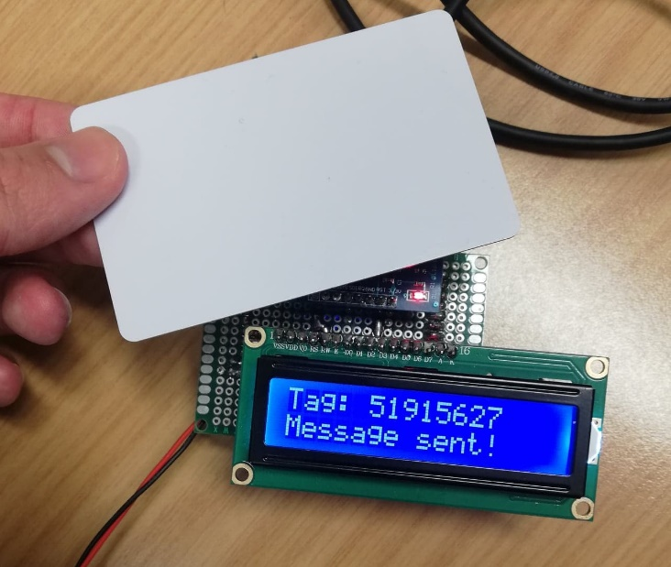

Figure 28. R.D.R electronic prototype

# 

# Shock of culture

## Cultural difference compared to lived experience

Concerning me, the shock of culture doesn’t be strong because I have Portuguese origin. In fact, my grandparents of my mother side lived near the city of Castelo Branco. So, I have family here. However, I found some changes in ma lived experience. I will talk about of difference between Portugal and France.

In the communication domain, I understand Portuguese when they speak slower, but we have the impression that they speak fast. This feeling is from the fact we don’t know this language, they speak at the same speed than French. The Portuguese language are easier to learn than French and each city don’t speak with the same accent. But compared to French, the Portuguese use approximately same words around Portugal. Sometime, the young people use different word to communicate. Most of this word come from Brazil because the Brazilian use simpler Portuguese language. At the beginning of my internship, With Portuguese, we tried to communicate in her language. But with the time, it’s become a little bit boring to communicate because we took more time to speak. Sometimes, it’s easier to find a better solution to communicate, for example using English. In the city where I was, the population are principally composed of peoples older than 50. So, it’s rare to meet people who speak French or English. During this period, I took more time with young people. Almost all spoke English with a good level. My observation it’s her level are better than French people. It’s probably because their language is most near the English than French and English are more present in daily life. For example, in cinema, the movies are in English with Portuguese subtitles. According to a study published by British council, Portuguese people are in 15th places of scoreboard of non-Anglophobe country with better level in English, compared to France at 17th places. Finally, on communication part, the Portuguese tend to speak with big gestures and to speak loudly. This is not a sign of aggression but rather of emotional involvement in the dialogue.

The food in Portugal are like that we know in France, whatever slightly spicier. Eating habits are the same (same number and mealtimes). The composition of plates doesn’t change fundamentally between French kitchen, because the same basics ingredients are used (potatoes, eggs, pasta, rice, flour …). No special attention is therefore required from this point of view.

The cost of life is cheaper in Portugal, especially in recreational, restauration, accommodation and transports. For example, a ticket of cinema cost 5 euros against 12 euros in France, we can easily eat on restaurant between 5 and 10 euros. For my accommodation, I paid 300 euros per month and at this price I has a 50 square metre with modern kitchen, washing machine, dishwasher and housekeeper. Compared to France, generally we paid between 700 and 1000 euros for this type of accommodation.

The climate in Portugal is “Mediterranean” with temperature up to 45 degree on summer and only 17 degree on average. But with this climate, it causes drought and fires.

Due to its Mediterranean climate, its environment and pleasant quality of life, Portugal is becoming one of the favourite destinations in Europe. In 2017, the country was able to welcome the record number of 21.2 million tourists, including 3.2 million French, and that hotel establishments registered 13 million customers, including 2 million French, an increase of 11 % compared to 2016. It’s much less than France with 82,85 million of tourist but this activity gives more economic boost in Portugal. So this domain is very important for Portuguese.

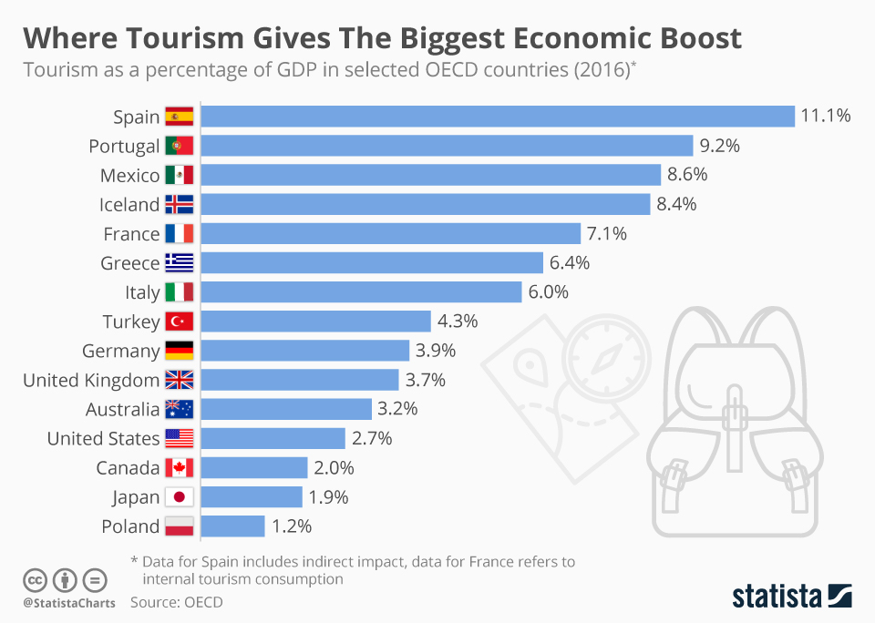

Figure 29. Tourism as a percentage of GDP in selected OECD countries (2016)

In the point of view of interpersonal and compartmental relationship, we feel a strongest strength compared to France. Portuguese are very respectful. During my internship, I never saw people in conflict on the street. They are warm et smiling. I find with my foreigner vision, I was well welcomed. I may have noticed, for example, that strong links has been made between student on university. We feel a general cohesion. I acted several times to see people help another, on the work and in daily life. They are also near their family and friends. Regarding to the country’s diversity, with the old Portuguese colony, Portugal contain population with multiple origin, they do not adopt any discriminatory comportment. Progress need to be accomplished in sexuality equality, and this despite efforts over the past several years in support of this principle.

I noticed of the Portuguese are very attached to traditional value (religious celebration, marriage…) because Portugal is one of most religious believers on catholic religion, also compared to France. However, they are open minded and respectful of difference. For illustrate my purpose, we can demonstrate it by the approval of marriage for everyone in 2010, well before France.

## Difference of practice in professional domain

In the professional context, I could see a real respect of hierarchy on school and companies. For example, like in France, we talk with our superior by “Mister” and their family name. However, I could see employees called her leaders by their surname. The dress style remains classic, everyone is free to dress as he wishes, unless it’s too extravagant. But in great company, we must have a suit to look like more reliable. Classic day of work begin approximately at 9 a.m., with a break lunch between 12 a.m. or 1 p.m. and 2 p.m. Portuguese work until 6 p.m. or 7 p.m. I could notice that Portuguese like to take time. For example, it’s arrived to begin meeting later or that they last longer. Despite, it’s not harmful to what one might think at first glance. The fact to have meeting longer is because temporality is not a constraint and it leads, in most cases, to interesting and useful project discussions. The climate of work is generally relaxed, it’s rare to see superior put pressure to its employees. This brings less stress and allows you to work in a good climate. The Portuguese are still very productive. Salaries are lower than in France, for example the minimum wage is 700 euros gross per month (against 1,521 euros in France).

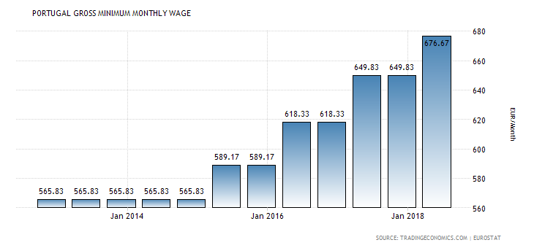

Figure 30. Average of gross salary on Portugal

However, the unemployment rate is 6.5% in Portugal against 8.5%. We see it very quickly by the superiority of the number of staff in companies. For example, at the gym where I was going to Portugal, there were constantly at least 5 staff, while in France, there are only 2 or 3 for roughly the same number of customers. We therefore have a lower salary but with a cheaper quality of life and a reduced unemployment rate compared to France. This is explained by the political context of the country because Portugal, after the 2008 crisis, underwent a more stringent but successful economic recovery.

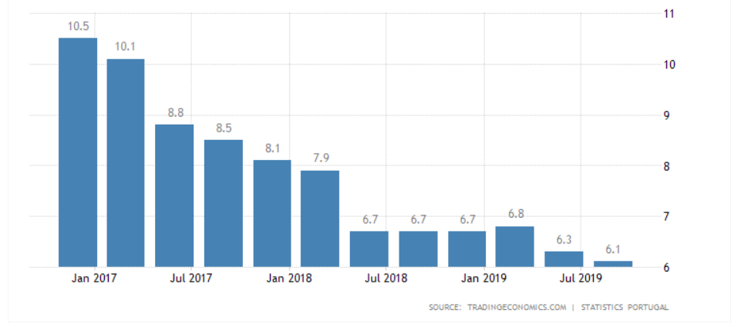

Figure 31. Unemployment rate in Portugal

Portuguese on company welcome you well. These are people who really like to have direct relationships, interpersonal relationships with people, so direct contact is important for establishing relationships. The external signs of wealth are of considerable importance. In France, you must arrive discreetly if you have a large car. In Portugal, on the contrary, they tend to show it.

# Conclusion

During this internship, I was able to improve my understanding of the different companies and projects for which I worked. Indeed, I studied the impact of IT in a sector of activity that differs from this field. For example, thanks to the project with R.D.R, I learned to take a step back to better study the customer's need. The different actors present us with a theoretical idea, it is our duty to respond to it technically while not losing sight of the objectives to be achieved.

It is therefore important to use engineering tools, such as Trello, Gantt, Git. Trello allows us to have a traceability of the different tasks that we must carry out. Coupling this tool with Gantt, allows us to add a temporality. So, I used these two tools to effectively respond to the two needs to which I responded. This allowed me to present the progress of the project to the rest of the team and to the client. We were also able to strategically plan the various interviews between the various project stakeholders. For example, for the bee project, we visited the hive site at the most opportune time. We also planned the implementation of the solution using these tools.

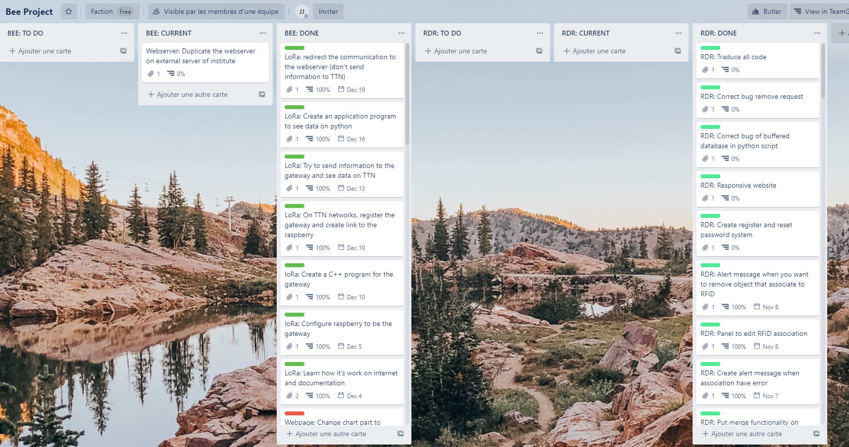

Figure 32. Screen of Trello for bee project and R.D.R

Our team, beforehand, had planned an implementation of the prototype over the period from January to February. So, we achieve this goal. The fact of working on two missions made the vision of the project more complex. However, we had decided to work in stages. In fact, the project change takes place according to the project deliverables. We study the need to cut out segments, the question was: from what point do you judge that it is interesting to switch solutions? In our case, we had chosen to realize the web solution (server, site, BDD) first on the two solutions because they included the same structure. Then we finished the practical part of R.D.R before starting the electronic part of bee project. Finally, we have made various rendering of projects for clients and the school.

As these two missions were carried out in two different contexts, I worked with two different teams. For RDR, I was in contact with teachers from my school, business leaders and an external IT department. I realized the part of the web solution in autonomy, while exchanging with the IT department for the choices on the implementation of the solution. I interacted with the leaders to learn more about the company and the need. With the teachers, we carried out daily updates on the progress of the project and on the possible modifications of the need.

On the bee project, I worked with a team of students from the school. We were supervised by my internship tutor and we interacted with the client. On the IT part, there were several of us on the realization, I proposed the use of a tool to work in common and perform a versioning of the code. So, we used Git technology with GitHub. For the missions, we had responded to the need for the entire.

In R.D.R. The need was to create a web solution to support the work of the decision support service by creating a parts storage system and a system for viewing and editing this information. So, we must realize:

* A complete database with information on car components and website users.
* A website with a view on the stock with the possibility of handling it according to the user rights on the site.
* All on a web server present in the company.

We also proposed an electronic system using RFID technology for adding or editing the quantities of components in the database. This allowed quick stock manipulation. Instead of adding all the components in the form of a form, we pass RFID cards in front of the reader and each card will relate to a component. The solution is in place with the client, we were waiting for their return on some modifications to be made for the future. The possible improvements on this project, would be to be able to add in the BDD all the storage locations, to be able to allow a more strategic storage (depending on the size available, the brand of vehicle…).

|  |  |  |  |  |  |
| --- | --- | --- | --- | --- | --- |
|  | Week 1 | Week 2 | Week 3 | Week 4 | Week 5 |
| Objective 1 |  |  |  |  |  |
| Objective 2 |  |  |  |  |  |
| Objective 3 |  |  |  |  |  |
| Objective 4 |  |  |  |  |  |
| Objective 5 |  |  |  |  |  |
| Objective 6 |  |  |  |  |  |
| Objective 7 |  |  |  |  |  |
| Objective 8 |  |  |  |  |  |

Figure 33. Planning of objectives on R.D.R project

|  |  |
| --- | --- |
| **Objective 1:** | Network management study |
| **Objective 2:** | Identification and study the technical features of the hardware used (Networking devices and Modules also used in project) |
| **Objective 3:** | Designing the architecture of the system and its blocks |
| **Objective 4:** | System development, including integration with electronics boards (integration between microprocessor and routers). |
| **Objective 5:** | Study and implementation of the services provide by server |
| **Objective 6:** | Implementation of solutions founded |
| **Objective 7:** | Development of a System Platform to the project that provides information about each variable on different car pieces |
| **Objective 8:** | Final System Testing and Validation |

For Bee project, the need was to create an IoT system allowing to remotely analyse the state of the hives and to intelligently process the data we received. We therefore realized:

* Electronic system with different sensors on the hives.
* A means of communication between the different components of the solution.
* A complete database with hive information and website users.
* A website with a vision on hive information and the possibility of defining an alert system.
* All on a web server present in the company.

The first solution was completed in full and the prototype was implemented at the customer's site to be able to recover data in real condition. The customer is satisfied with the solution because it meets these expectations. The points to bring for the second version of the project is:

* Website design.
* New features on the site such as graphs with coupled views (example, temperature and weight measurement), the possibility of sending alerts on the phone, a General view which gives the state of the hives, a restriction of views according to the users, a site or application on mobile with the possibility of scanning the hives on the spot thanks to a QR code and having the state of the hive.
* Adding new sensors.

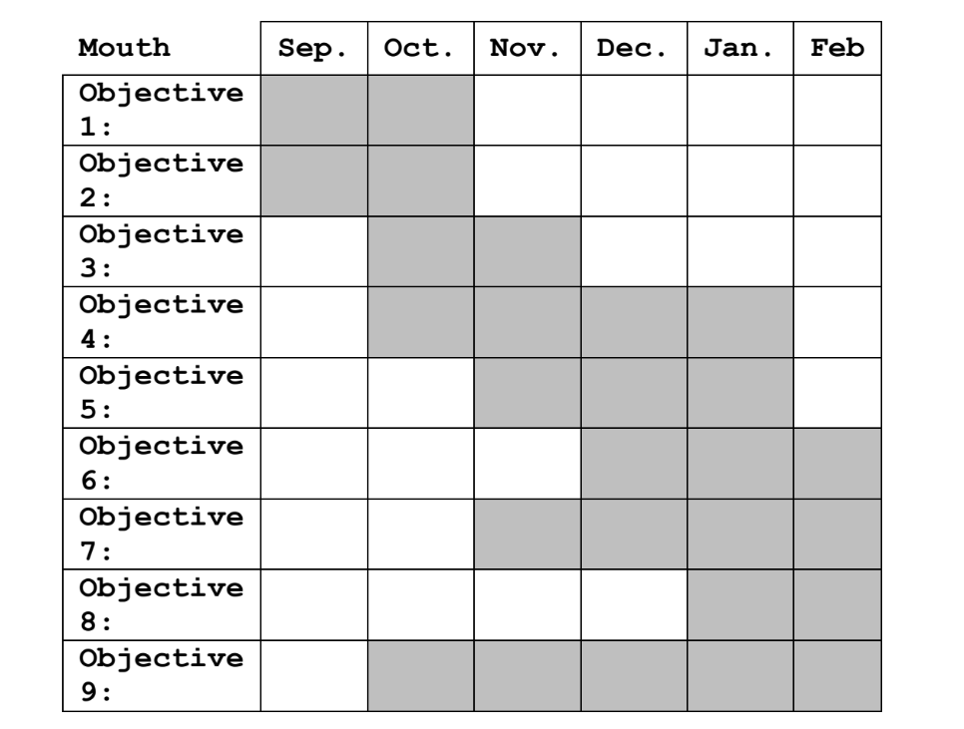

Figure 34. Planning of objectives on bee project

|  |  |
| --- | --- |
| **Objective 1:** | Network management study |
| **Objective 2:** | Identification and study the technical features of the hardware used (Networking devices and Modules also used in project) |
| **Objective 3:** | Designing the architecture of the system and its blocks |
| **Objective 4:** | System development, including integration with electronics boards (integration between microprocessor and routers). |
| **Objective 5:** | Study and implementation of the services provide by server |
| **Objective 6:** | Implementation of solutions founded |
| **Objective 7:** | Development of a System Platform to the project that provides information about each variable on different beehives |
| **Objective 8:** | Final System Testing and Validation |
| **Objective 9:** | Writing the Internship Report and other documentations needed |

For the realization of these projects, I decided to write different documents such as procedures, user guides or report on the overall operation of the solution. This will allow the different actors to be able to continue or develop the solution after my departure. I also used design patterns for the realization of the website like the MVC and DAO pattern to be able to develop while following good coding practices. This allows future developers to have a solid structure for future improvements. Finally, I offered them solutions for managing projects like using Gantt, Trello, Git.

I was able to acquire during this internship more knowledge in the field of IoT, telecommunications and decision-making. I was able to put into practice the engineering techniques to carry out the various projects. I learned to adapt the Portuguese working methods, and to communicate mainly in English.

## Conclusion of career path

As part of my professional project, this strengthened my choice to go into the field of entrepreneurship. When I worked on bee project, I appreciated the entrepreneurial dimension of this project. We exchanged with different beekeepers to talk about the idea and to have funding for the realization of the solution. It’s not a simple field because one does not profit from the same stability as working for a company, but I think that it is the most opportune moment to try in this domain because it’s the period we don’t have too many constraints and responsibilities.

## Conclusion of culture

For conclude the culture parts, during this internship, I could know better the Portuguese culture and improve my experience on the field of work in a foreign company. Compared to my precedent internship in South Korea, the shock of culture on daily life was not the same. I felt less disoriented through of my Portuguese origins and the similarity between French culture because they are together in Europe. This may sound weird, but we have impression that the climate of country, the state of country, the beliefs have a real impact about the comportment of people in society. As we have differences on this point with Portugal, we could notice some changes in communication, interpersonal relationship and individual and collective behaviour.

In the professional domain, I could see some changes about of people works. The geo-political and sociological context influences the societies of the country. However, in Portugal there is not much difference compared to France. we find the same respect for hierarchy and similar working methods. What changes is the relaxed attitude of the employees, but they remain just as productive. Portuguese people prefer to work in a Zen climate, and it succeeds.

# References

**School presentation parts:**

<https://www.ipcb.pt/>

<https://www.ipcb.pt/estcb/escola-superior-de-tecnologia>

**Culture parts:**

<https://www.tresor.economie.gouv.fr/Articles/961aadfc-1b24-4f96-bf80-6479f96e9dc9/files/1e577d96-ccc4-4111-982d-e67756272d0e>

<https://www.usinenouvelle.com/article/l-ingenieur-a-la-francaise-une-valeur-sure-meme-a-l-etranger.N64080>

<https://www.diplomatie.gouv.fr/fr/services-aux-francais/preparer-son-expatriation/dossiers-pays-de-l-expatriation/portugal/vie-pratique/article/environnement-culturel>

<https://www.ipcb.pt/sites/default/files/upload/sc/files/docs_gestao/plano_actividades_aprovado_em_conselho_geral_08_01_2019.pdf>

<https://www.ipcb.pt/sites/default/files/upload/sc/files/docs_gestao/plano_estrategico_aprovado_em_conselho_geral_08_01_2019.pdf>

**Bee project parts:**

<https://itsap.asso.fr/pages_thematiques/gestion-du-cheptel-et-production/ruche-connectee-objet-de-surveillance-environnementale-de-zootechnie-de-decouverte-recreative/>

<https://fr.wikipedia.org/wiki/Apiculteur>

<http://www.cari.be/medias/abcie_articles/161_voyage.pdf>

<https://www.gpp.pt/images/Programas_e_Apoios/Apoios_de_Mercado/PAN/PAN2017-2019.pdf>

<https://www.digora.com/fr/blog/definition-iot-et-strategie-iot>

**R.D.R project**

<http://www.rdr-reciclagem.pt/>

<https://en.wikipedia.org/wiki/Decision_support_system>